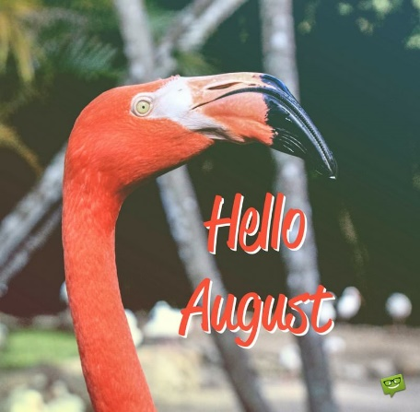

* August 3rd- Skaters Edge- Bus Departs Kiddie College at 12:05 PM- returns to the center at 3:15 PM
* August 10th- Building for Kids- Bus departs kiddie college at 8:20 AM- returns to the center at 1:30 PM.
* August 17th- The Courses- Bus departs Kiddie College at 8:20 AM- returns to the center at 1:30 PM.
* August 24th- Luv 2 Play- Bus departs Kiddie College at 9:20 AM- returns to the center at 1:30 PM.

Happy Birthday!

* Julia E- 8/05
* Lauren G- 8/12
* Liam B- 8/16
* CeCe M- 8/18
* Abel K- 8/19
* Cooper B- 8/22
* Camden B- 8/28
* Mackenzie G- 8/28

---------------

* Miss. Payton- 08/16

***Parent Information:***

* *There is a new feature on Brightwheel that allows you to message administration staff only (Jayme or Debi). These messages are not seen by any other staff member, if your message is intended to go to your child’s teacher, please make sure that you are not choosing Admin only message.*
* *The end of summer is approaching fast, if you haven’t let us know your fall plans for childcare, we need to know ASAP to make sure that we have the proper arrangements made out for this fall.*
* *Please make sure that you are following your schedule, it is extremally hard to staff when people are dropping off earlier than their scheduled times or picking up later than their scheduled times*
* *If you don’t need a paper (handwritten) receipt, please let Jayme know.*