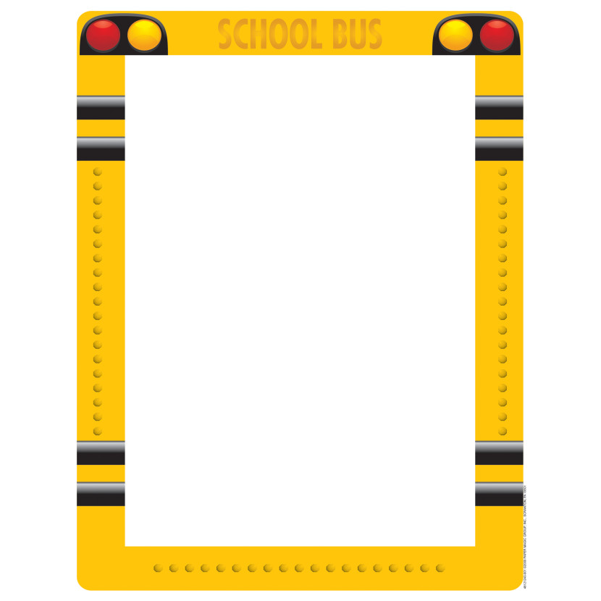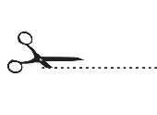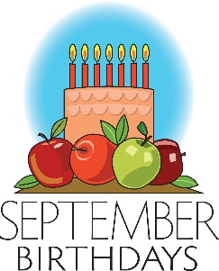

**Parent Information:**

* As a reminder, we will be closed on Monday September 7th for Labor Day.
* We will have Pajama Day at the center on Friday September 18th!
* As the weather begins to change, please make sure your child(ren) have weather appropriate clothing at the center.
* The department of children and families have come up with an amendment to the sick child policy, there is a copy attached for your reference and a copy that you need to sign and return to the center. As a licensed child care center we need to follow this policy until further notice.
* Again, scheduling has become extremely difficult. It seems like children are coming and going from the center at all times of the morning and afternoon. It is important that you let us know any schedule changes that you may have, in advance, so we can schedule the appropriate amount of staff at the center. If you could turn in the bottom slip with your child’s hours so we can staff the center it would be greatly appreciated.
* Skip ahead to November, as a reminder we are closed for Thanksgiving (Nov. 26) and the day after Thanksgiving (Nov 27), so please plan accordingly.

Children’s Schedule Slip:

Child (rens) Name(s)___________________________

____________________________________________

Hours: _______________ to ____________________

* Jimmy F- 09/02
* Reina L- 09/05
* Cain G- 9/08
* Nora M- 09/14
* Aubrie N- 09/14
* Brantley F- 09/17
* Lily B- 09/18
* Isabella B- 09/20
* Emmalyn E- 09/22
* Easton J- 09/28