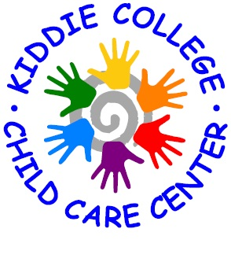
Kiddie College Menu
For the week of: January 20th to January 24th 2020
 | Monday  20 | Tuesday  21 | Wednesday  22 | Thursday  23 | Friday  24
Breakfast | Strawberry Mini Scoops  Honey Kix  Banana  Whole Milk  Skim Milk (^2) | French Toast Sticks  Syrup  Warm Apples  Whole Milk  Skim Milk (^2) | Snickerdoodle breakfast Bread  Yogurt  Whole Milk  Skim Milk (^2) | Scrambled Eggs  Sausage Links  Mixed Berries  Whole Milk  Skim Milk (^2) | Apple Cinnamon Breakfast Bars  Applesauce  Whole Milk  Skim Milk (^2)
Lunch | Chicken and Rice Casserole  Carrots  Pears  Whole Milk  Skim Milk (^2) | Rib Patty Sandwich  Broccoli  Mandarin Oranges  Whole Milk  Skim Milk (^2) | Spaghetti w/ Meat Sauce  Peas  Pineapple  Whole Milk  Skim Milk (^2) | Fish Sticks  Ketchup  Corn  Peaches  Whole Milk  Skim Milk (^2) | Pizza Slices  Green Beans  Apricots  Whole Milk  Skim Milk (^2)
Snack | Graham Crackers  Hot Chocolate Dip  Whole Milk  Skim Milk (^2) | Veggie Straws  100% Assorted Juice | Muffins  Apple Slices  Whole Milk  Skim Milk (^2) | Vanilla Wafers  Orange Slices  Whole Milk  Skim Milk (^2) | Peanut Butter and Jelly  Sandwiches  Whole Milk  Skim Milk (^2)

